BCA
III SEMESTER
PYTHON PROGRAMMING LAB
Total Hours: 20 per batch Hours/Week: 2
Max Marks: 50 Credits: 2
Choose any 15 programs.
PART A: qq
- Write a program to demonstrate different number data types in python.
- Write a program to perform different arithmetic operations on numbers in python
- Write a program to perform different string operations.
- Write a python script to print the current date
- Write a python program to perform list operations in python.
- Write a program to demonstrate working with tuples in python
- Write a program to demonstrate working with dictionaries in python
- Write a program to demonstrate working of if..else if in Python
- Write a program to calculate sum of series
- Write a python program to find factorial of a number using recursion

PART B:

- Write a python program to define a module to find Fibonacci Numbers and import the module to another program
- Write a script named copyfile.py. This script should prompt the user for the
names of two text files. The contents of the first the second file..
- Write a program to compute area of following shapes: circle, rectangle and triangle
- Write a program to reverse the given number
- Write Python program to demonstrate math built- in functions
- Write a program in Python to handle user defined exception for given problem
- Write a program using a while loop that asks the user for a number, and prints a countdown from that number to zero.
- Write a program to find mean, median, mode for the given set of numbers in a list.
- Write a program find even sum and odd sum for given range of numbers
- Write a program to check if the given string is palindrome or not.

Program 1
# Python program to demonstrate the numeric values.
a = 5
print(“ Value of a is: ”, a)
print("Type of a: ", type(a))
b = 5.0
print(“ Value of b is: ”, b)
print("\nType of b: ", type(b))
c = 2 + 4j
print(“ Value of c is: ”, c)
print("\nType of c: ", type(c))

Program 2

# Python program to perform arithmetic operations.
# Receiving the input
num1 = input('Enter first number: ')
num2 = input('Enter second number: ')

# Arithmetic operations
sum = float(num1) + float(num2)
min = float(num1) - float(num2)
mul = float(num1) * float(num2)
div = float(num1) / float(num2)

# Printing the results
print('The sum of {0} and {1} is {2}'.format(num1, num2, sum))
print('The subtraction of {0} and {1} is {2}'.format(num1, num2,
min))
print('The multiplication of {0} and {1} is {2}'.format(num1, num2,
mul))
print('The division of {0} and {1} is {2}'.format(num1, num2, div))

Program 3
# Python program to demonstrate string operations.
str1="Welcome you all students"
capital=str1.upper()
print(capital)
small=capital.lo
wer()
print(small)

str2=str1.replace("students","engineers")
print(str2)

st=" This is an example of strip "
left=st.lstrip()
print(left)

right=st.rstrip()
print(right)

#The startswith() method returns True if the string starts with the specified value, otherwise False
prefix1=str1.startswith("Welcome ")
print(prefix1)

prefix2=str2.startswith("s")
print(prefix2)

#The endswith() method returns True if the string ends with the specified value, otherwise False.
prefix3=str2.endswith("w")
print(prefix3)

Program 4
#Python program to print the current date.
from datetime import date
today = date.today()

# dd/mm/YY
d1 = today.strftime("%d/%m/%Y")
print("d1 =", d1)

# Textual month, day and year
d2 = today.strftime("%B %d, %Y")
print("d2 =", d2)

# mm/dd/y
d3 = today.strftime("%m/%d/%y")
print("d3 =", d3)

# Month abbreviation, day and year
d4 = today.strftime("%b-%d-%Y")
print("d4 =", d4)

program5
5. Write a python program to perform list operations.
# Creating a List
List = [1,2,3]
print("Initial List: ")
print(List)
List.append(2)
List.append(4)
print("\n List after Addition of Two elements: ")
print(List)

# Addition of Element at specific Position using Insert Method
List.insert(3,12)
List.insert(4,14)
print("\n List after performing Insert Operation: ")
print(List)

# Removing elements from List using remove() method
List.remove(1)
List.remove(2)
print("\n List after Removal of two elements: ")
print(List)

# Print elements of a range using Slice operation
Sliced_List = List[2:4]
print("\nSlicing elements in a range 2-4: ")
print(Sliced_List)

# Addition of List to a List using append () method
List2 = [8,10]
List.append(List2)
print("\n List after Addition of a List: ")
print(List)

Output:
Initial List:
[1, 2, 3]
List after Addition of Three elements:
[1, 2, 3, 2, 4]
List after performing Insert Operation:
[1, 2, 3, 12, 14, 2, 4]
List after Removal of two elements:
[3, 12, 14, 2, 4]
Slicing elements in a range 2-4:
[14, 2]
List after Addition of a List:
[3, 12, 14, 2, 4, [8, 10]]

Program 6
6. Write a program to demonstrate working with Tuples.
# Creating an empty Tuple
Tuple1 = ()
print("Initial empty Tuple: ")
print(Tuple1)
# Creating a Tuple with the use of string
Tuple2 = ('Chennai', 'Delhi')
print("\nTuple with the use of String: ")
print(Tuple2)
# Creating a Tuple with the use of list
list1 = [1, 2, 4, 5, 6]
print("\nTuple using List: ")
print(tuple(list1))
# Creating a Tuple with the use of built-in function
Tuple3 = tuple('Bengaluru')
print("\nTuple with the use of function: ")
print(Tuple3)

# Printing the values of Tuple
print("\nFirst element of Tuple: ")
print(Tuple3[0])
# Tuple unpacking. This line unpack values of Tuple2
a, b = Tuple2
print("\nValues after unpacking: ")
print(a)
print(b)

Output:
Initial empty Tuple:
()
Tuple with the use of String:
('Chennai', 'Delhi')
Tuple using List:
(1, 2, 4, 5, 6)

Tuple with the use of function:
('B', 'e', 'n', 'g', 'a', 'l', 'u', 'r', 'u')
First element of Tuple:
B
Values after unpacking:
Chennai
Delhi

Program 7: Write a program to demonstrate dictionaries in python.
# demo for all dictionary methods
dict1 = {1: "Python", 2: "Java", 3: "Ruby", 4: "Scala"}
# copy() method
dict2 = dict1.copy()
print(dict2)
# clear() method
dict1.clear()
print(dict1)
# get() method
print(dict2.get(1))
# items() method
print(dict2.items())
# keys() method
print(dict2.keys())

# pop() method
dict2.pop(2)
print(dict2.pop(2))
# popitem() method
dict2.popitem()
print(dict2)
# update() method
dict2.update({3: "Scala"})
print(dict2)
# values() method
print(dict2.values())
Output:
{1: 'Python', 2: 'Java', 3: 'Ruby', 4: 'Scala'}
{}
Python
dict_items([(1, 'Python'), (2, 'Java'), (3, 'Ruby'), (4, 'Scala')])
dict_keys([1, 2, 3, 4])
{1: 'Python', 3: 'Ruby', 4: 'Scala'}
{1: 'Python', 3: 'Ruby'}
{1: 'Python', 3: 'Scala'}
dict_values(['Python', 'Scala'])

Program 8
# Write a program to demonstrate working of if..else if in Python
name = input("Enter your Name:")
regno = input("Enter your Reg.No. :")
marks = int(input("Enter your Average Mark: "))
print("********************************************************")
print("Result: ", regno, name)

if marks >= 75 and marks <= 100:
print("Congrats ! you passed in First class with Distinction...")
elif marks >= 60 and marks < 75:
print("Congrats ! you passed in First class ...")
elif marks >= 50 and marks < 60:
print("You passed in Second class ...")

elif marks >= 40 and marks <50:
print("You passed in Pass class ...")
else:
print("Sorry, you failed")
print("********************************************************")

Program 9
Write a program to calculate sum of series
n=int(input("Enter the value of 'n' = "))
sum = 0
for i in range(1,n+1):
sum=sum+i

print("Sum of the series is",sum)

Output:
Enter the value of 'n' = 10
Sum of the series is 55

Program 10
Program to find factorial of given number

def factorial(n):
# Checking the number is 1 or 0 then return 1 other wise return
factorial
if (n == 1 or n == 0):
return 1
else:
return (n * factorial(n - 1))
num = int(input("Enter a number: "))
print("number : ", num)
print("Factorial : ", factorial(num))

Output:
Enter a number: 5
number : 5
Factorial : 120

Program 11
Program to define a module to find the Fibonacci series and importing to another program.

Program name is fib.py

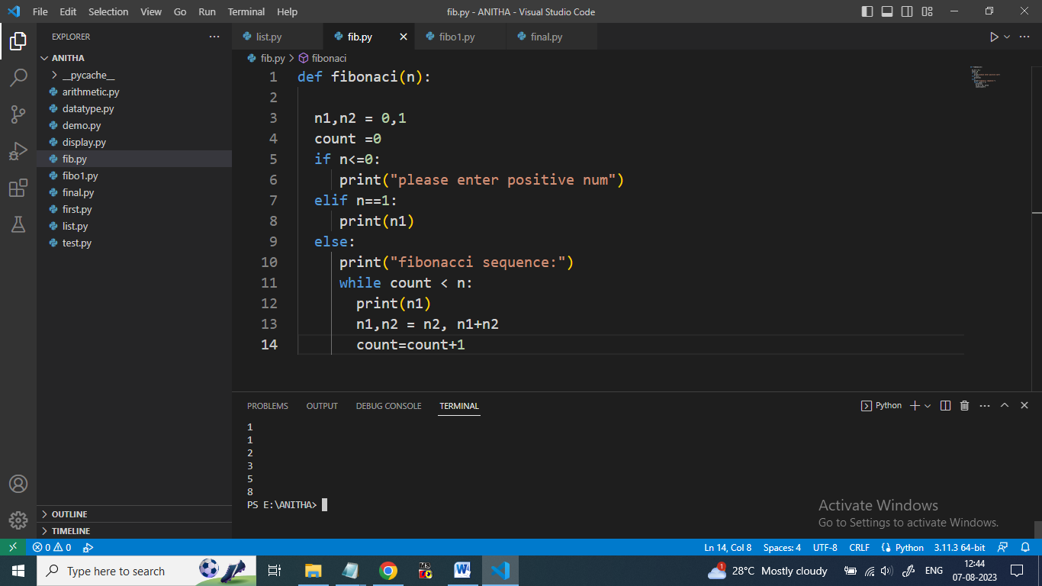

Program name is mainFib.py
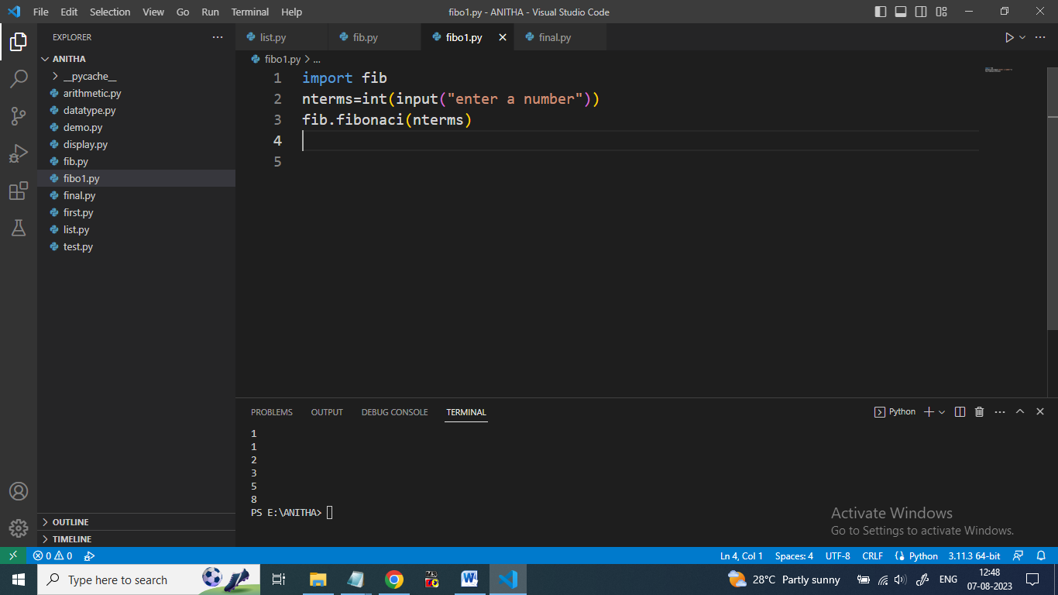
Output:
Enter the number to generate the Fibonacci series:5
0 1 2 3 5

Name: fibo.py
def fibo(n):
n1,n2 = 0,1
count =0
if n<=0:
print("please enter positive num")n
elif n==1:
print(n1)
else:
print("fibonacci sequence:")
while count < n:
print(n1)
n1,n2 = n2, n1+n2
count=count+1
----------------------------------------
fiboMain.py
import fib
nterms=int(input("enter a number"))
fib.fibo(n)

Program 12
Write a script named copyfile.py. This script should prompt the user for the names of two text files. The contents of the first the second file..

print("Enter the Name of Source File: ")
sFile = input()
print("Enter the Name of Target File: ")
tFile = input()

fileHandle = open(sFile, "r")
texts = fileHandle.readlines()
fileHandle.close()

fileHandle = open(tFile, "w")
for s in texts:
fileHandle.write(s)
fileHandle.close()

print("\nFile Copied Successfully!")

print("Enter the Name of Source File: ")
sFile = input()
print("Enter the Name of Target File: ")
tFile = input()

fileHandle = open(sFile, "r")
texts = fileHandle.readlines()
fileHandle.close()

fileHandle = open(tFile, "w")
for s in texts:
fileHandle.write(s)
fileHandle.close()

print("\nFile Copied Successfully!")

Enter the Name of Source File:file1.txt
Enter the Name of Target File:file2.txt
File Copied Successfully!
Program 13
Write a program to calculate the area of Circle,Rectangle, and Triangle.
print ( "1-rectangle, 2-triangle, 3-circle" )
figure = input ( "Select a shape:" )
if figure == '1' :
print ( "The lengths of the sides of the rectangle:" )
a = float (input ( "a =" ))
b = float (input ( "b =" ))
print ( "Area:% .2f" % (a * b))
elif figure == '2' :
print ( "The lengths of the sides of the triangle:" )
a = float (input ( "a =" ))
b = float (input ( "b =" ))
c = float (input ( "c ="))
p = (a + b + c) / 2
from math import sqrt
s = sqrt (p * (p - a) * (p - b) * (p - c))
print ( "Area:% .2f" % s)
elif figure == '3' :
r = float (input ( "Circle radius R =" ))
from math import pi
print ( "Area:% .2f" % (pi * r ** 2 ))
else :
print ( "Input error" )
Output:
1-Rectangle, 2-Triangle, 3-Circle
Select a shape:1
The lengths of the sides of the rectangle:
a =3
b =4
Area: 12.00
1-Rectangle, 2-Triangle, 3-Circle
Select a shape:2
The lengths of the sides of the triangle:
a =3
b =5
c =6
Area: 7.48
1-Rectangle, 2-Triangle, 3-Circle
Select a shape:3
Circle radius R =5
Area: 78.54

Program 14
Write a program to reverse the given number
Number = int(input("Please Enter any Number: "))
Reverse = 0
while (Number > 0):
Reminder = Number % 10
Reverse = (Reverse * 10) + Reminder
Number = Number // 10
print("\n Reverse of entered number is = %d" % Reverse)

Output:
Please Enter any Number: 123
Reverse of entered number is = 321

Program 15
Built-in math functions
import math
sq = math.sqrt(64)
ce = math.ceil(1.4)
fl = math.floor(1.4)
p = math.pi
po = pow(4, 3)
mi = min(5, 10, 25)
ma = max(5, 10, 25)
ab = abs(-7.25)
anglDegree = 90
anglRadian = math.radians(anglDegree)
print('sqrt(64) is:', sq)
print('ceil(1.4) is:', ce)
print('floor(1.4) is:', fl)
print('pi(1.4) is:', p)
print('pow(4,3) is:', po)
print('min(5,10,25) is:', mi)
print('max(5,10,25) is:', ma)
print('abs(-7.25) is:', ab)
print('The given angle is :', anglRadian)
print('sin(x) is :', math.sin(anglRadian))
print('cos(x) is :', math.cos(anglRadian))
print('tan(x) is :', math.tan(anglRadian))

Output:
sqrt(64) is: 8.0
ceil(1.4) is: 2
floor(1.4) is: 1
pi(1.4) is: 3.141592653589793
pow(4,3) is: 64
min(5,10,25) is: 5
max(5,10,25) is: 25
abs(-7.25) is: 7.25
The given angle is : 1.5707963267948966
sin(x) is : 1.0
cos(x) is : 6.123233995736766e-17
tan(x) is : 1.633123935319537e+16
Program 16
Write a program in Python to handle user defined exception for given problem
class FiveDivisionError(Exception):
#this is exception class called when five division error happens
pass
try:
n1=int(input("Enter first number:"))
n2=int(input("Enter second number:"))
if(n2==5):
raise FiveDivisionError("cannot divide by five")
div=n1/n2
print("division is:",div)
except (FiveDivisionError,ZeroDivisionError) as var:
print(var)
Output1:
Enter first number:4
Enter second number:5
cannot divide by five
Output2:
Enter first number:4
Enter second number:3
division is: 1.3333333333333333

Program 17
Write a program using a while loop that asks the user
for a number, and prints a countdown from that number to zero.
n = int(input("Enter A Number--->"));
while n >=0:
print (n);
n = n - 1;
Output:
Enter A Number--->8
8
7
6
5
4
3
2
1
0

https://evidencen.com/3-ways-to-calculate-mean-median-and-mode-in-python/

Program 18
Write a program to find mean, median, mode for the given set of numbers in a list.

numbers=[1,2,3,4,5,6,8,8,9,8,7,8,5,6,3,8,2,8,10,11,1,8,5,8,9,3,25,5,6,47,1,2]

#Mean is described as the total sum of the numbers in a list divided by the length of the numbers in the list
mean=sum(numbers)/len(numbers)
print(mean)

#median is described as the middle number when all numbers are sorted from smallest to largest

# // means to "divide and round to the next smallest whole number"

#first sort the number in increasing order
#then divide the length of the sorted number by 2

median=sorted(numbers) [len(numbers) // 2 ]
print (median)

#mode is described as the most frequent occuring number when all numbers are sorted from smallest to largest

#first figure out what the maximum number is
#then count how many times maximum number occurs
mode=max(numbers, key=numbers.count)
print(mode)

Calculation of Mean, Median and Mode
from collections import Counter
num = list(map(int,input("Enter the numbers:").split()))
n = len(num)
# Calculation of Mean
sum = sum(num)
mean = sum / n
print("Mean is: ", mean)
# Calculation of Median
num.sort()
if n % 2 == 0:
median1 = num[n//2]
median2 = num[n//2 - 1]
median = (median1 + median2)/2
else:
median = num[n//2]
print("Median is: ", median)
# Calculation of Mode
data = Counter(num)
get_mode = dict(data)
mode = [k for k, v in get_mode.items() if v ==
max(list(data.values()))]
# {key:value for key, value in iterable if condition}
if len(mode) == n:
get_mode = "No mode found"
else:
get_mode = "Mode is/are: " + ', '.join(map(str, mode))
print(get_mode)
Output:
Enter the numbers:2 2 2 3 4 5 6 7 8
Mean is: 4.333333333333333
Median is: 4
Mode is/are: 2
Program 19
Write a program find even sum and odd sum for given
range of numbers
maximum = int(input(" Please Enter the Maximum Value : "))
even_total = 0
odd_total = 0
for number in range(1, maximum + 1):
if (number % 2 == 0):
even_total = even_total + number
else:
odd_total = odd_total + number
print("The Sum of Even Numbers from 1 to {0} = {1}".format(number,even_total))
print("The Sum of Odd Numbers from 1 to {0} = {1}".format(number,odd_total))

Output:
Please Enter the Maximum Value : 10
The Sum of Even Numbers from 1 to 10 = 30
The Sum of Odd Numbers from 1 to 10 = 25
Program 20
Write a program to check if the given string is palindrome or not
#using built-in function
word = input("Enter any word: ")
rev = reversed(word)
if list(word)==list(rev):
print('It is a palindrome')
else:
print('It is not a palindrome')
#Palindrome program in python without using built-in function
string=input("Enter any word:")
if(string==string[::-1]):
print('It is a palindrome')
else:
print('It is not a palindrome')

Output:
Enter any word: madam
It is a palindrome
Enter any word: hello
It is not a palindrome

